LINUX
ASSIGNMENT

Submitted By :- Akash Yadav
1.Create a directory "exercise" inside your home directory and create nested(dir1/dir2/dir3) directory structure inside "excerise" with single command.
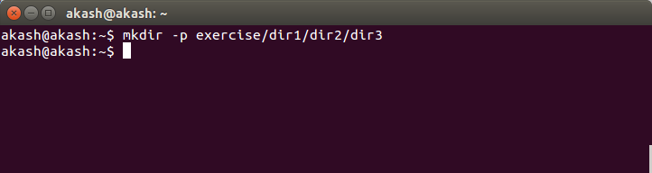
2.Create two empty files inside dir: emptyFile1,emptyFile2 in single command and Remove the dir2 direcroty
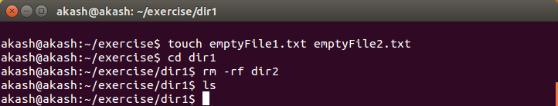
3.Create one file file.txt containing text "hello world" and save it.
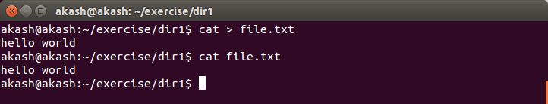

Or

echo “hello world” > file.txt

4.Find a "passwd" file using find command inside /etc. copy this files as passwd_copy and then rename this file as passwd_backup.
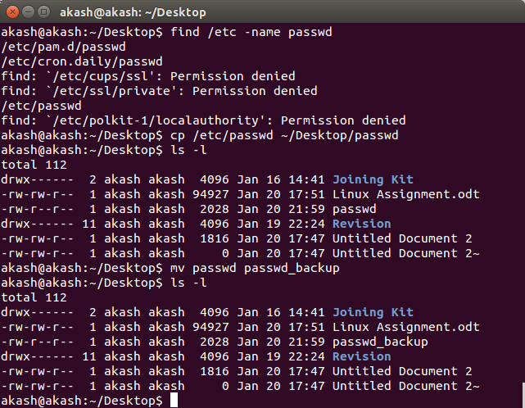
5.Try reading passwd_backup file in multiple tools: less,more,cat,strings etc and find the difference in their usage.

more = to view a text file one page at a time, press spacebar to go to the next page
more filename : show the document one page at a time
more -num filename : show the document page few lines as specified bu (-num)
example : more -10 passwd_backup will show 10 lines for every page
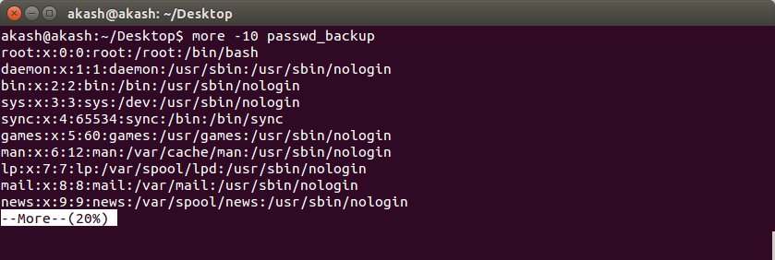
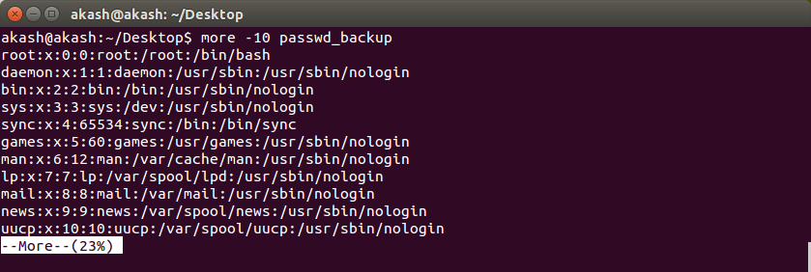
.
less = is much the same as more command except:
a) You can navigate the page up/down using the less command and not possible in more command.
b) You can search a string in less command. (use /keyword to search)
c) “more” was fairly limited, and additional development on “more” had stopped
d) it uses same functions as vi editor
the usage : less passwd_backup
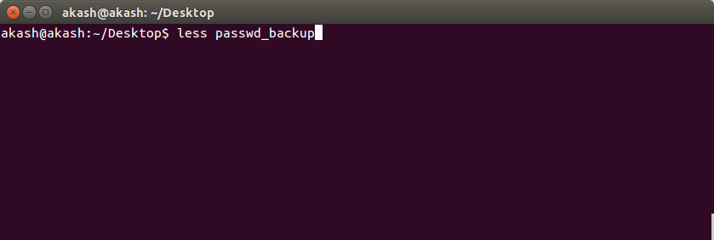
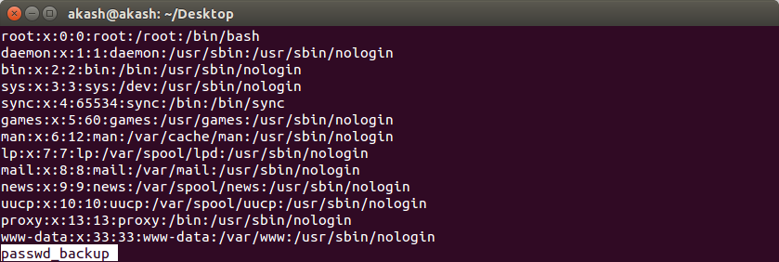
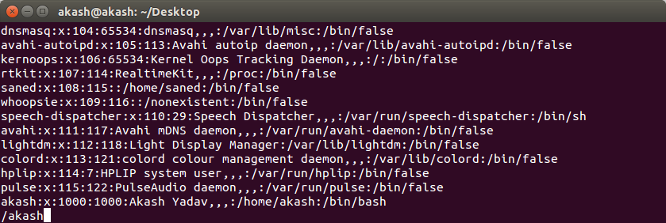
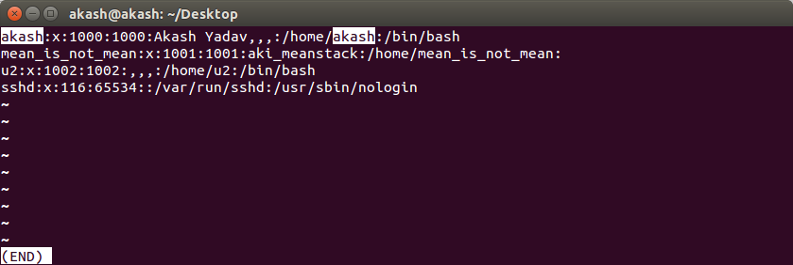
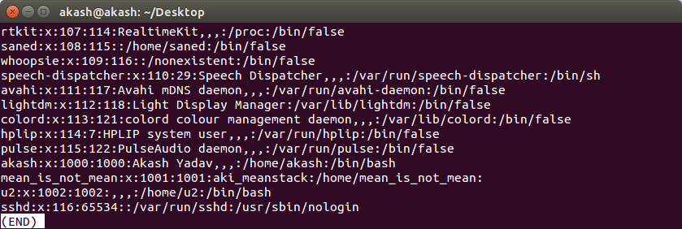
.

head = displays the first ten lines of a file, unless otherwise stated.
Examples
head passwd_backup – Would display the first ten lines of myfile.txt.
head -15 passwd_backup – Would display the first fifteen lines of myfile.txt.
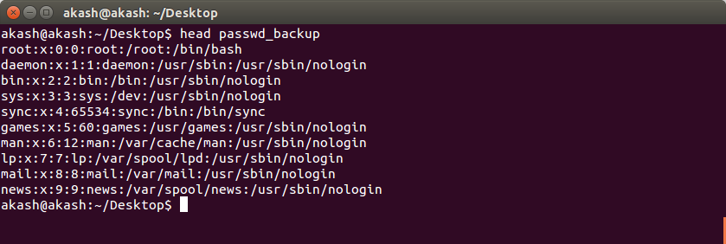
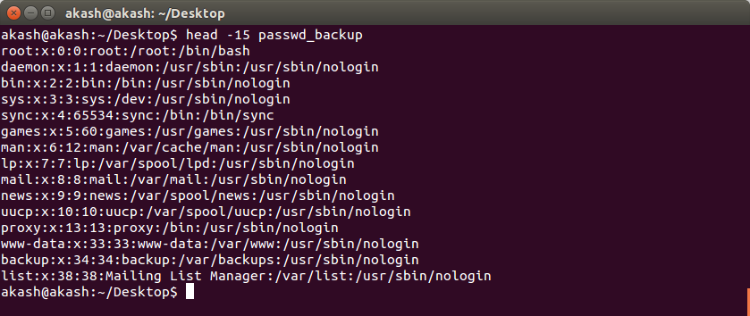
.

tail = display the last part of the file
usage : tail passwd_backup
tail -n passwd_backup : display the last n lines of the file
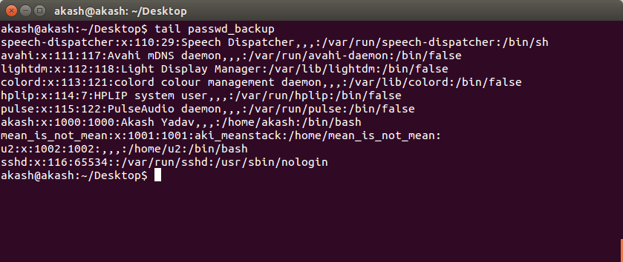
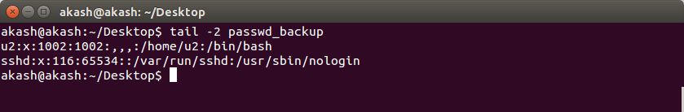
cat = can be used to join multiple files together and print the result on screen (it will not show page by page)
usage:
cat passwd_backup
to display the contents of file passwd_backup
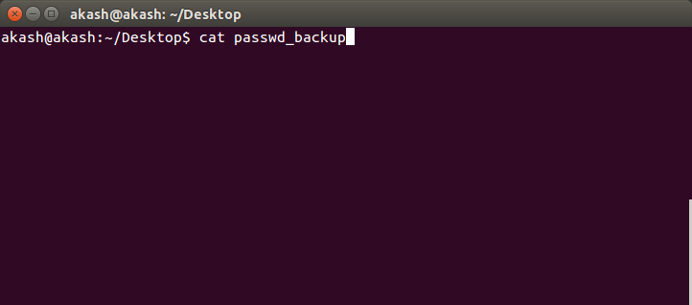
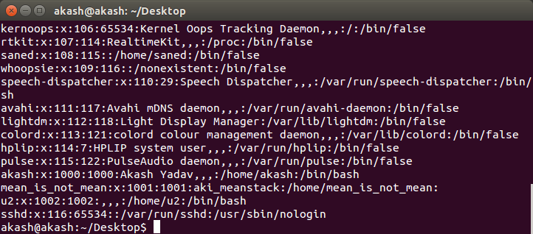
More Options
cat 01.txt 02.txt
to display the contents of both files
cat file1.txt file2.txt > file3.txt – Reads file1.txt and file2.txt and combines those files to make
cat note5 >> notes – attach note5 to notes
cat >> file1 – add additional data in file1

6.Find out the number of line in password_backup containing "/bin/false".
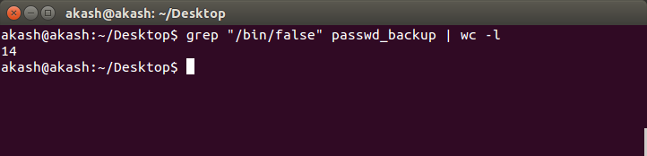
7.Redirect the output of the above commands into file "output".
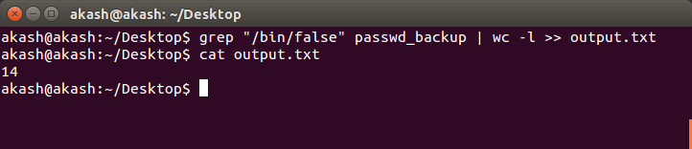
8.Create a "test" user,create its password and find out its uid and gid.
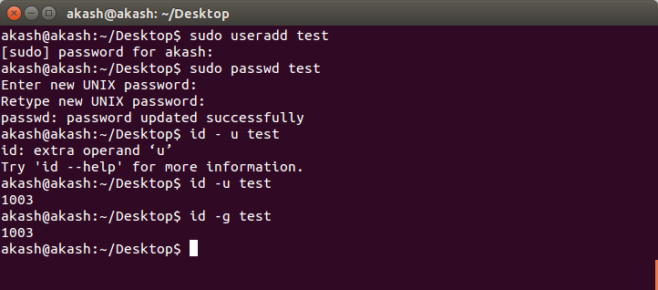

9.Login as test user and edit the "output" file created above. Since the permission wont allow you to save the changes.

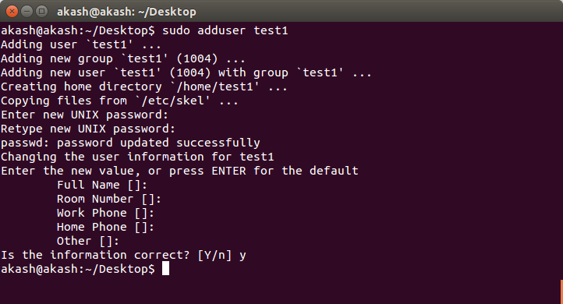

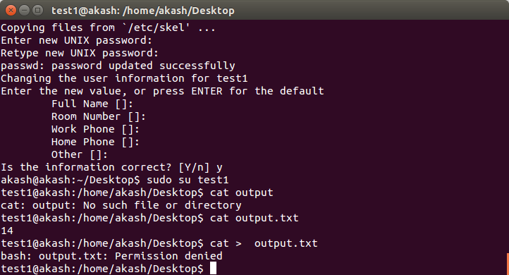
OR

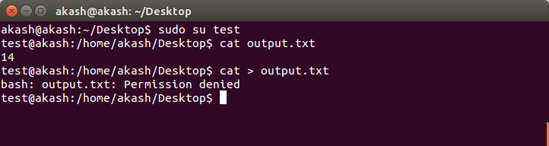

10. Configure such that test user can edit it.
a. Add group owner of the "output" file as the secondary secondary group of testuser and check/change the "output" file permission if it is editable by group. Once done revert the changes.

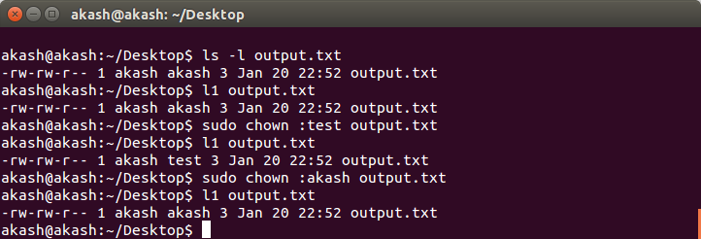
b. Make the file editable to the world so that test user can access it. Revert the changes after verification

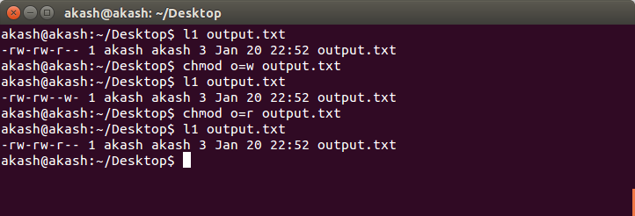

c. Change the ownership to edit the file.

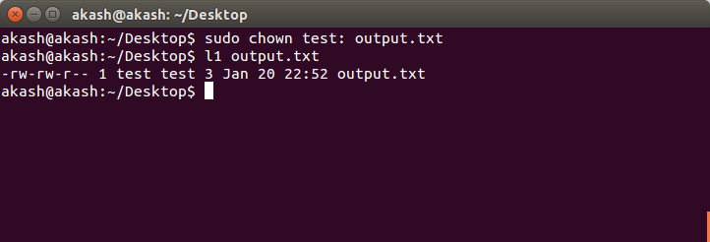

11.Create alias with your name so that it creates a file as "/tmp/aliastesting".

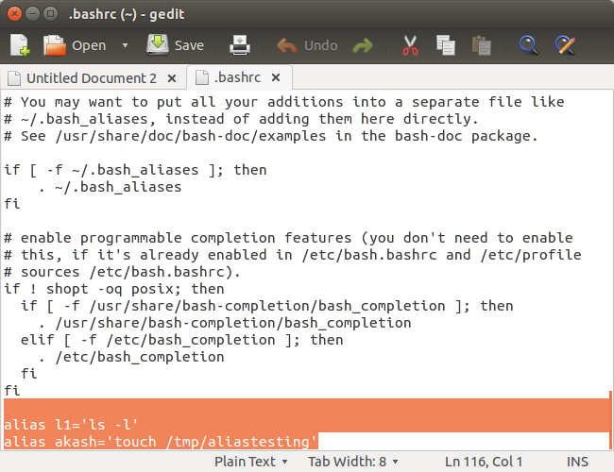
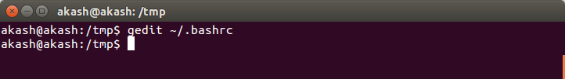

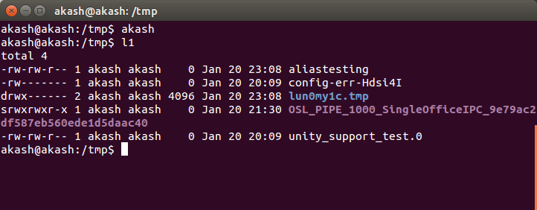

12. Edit ~/.bashrc file such that when you change to "test" user it should clear the screen and print "Welcome".

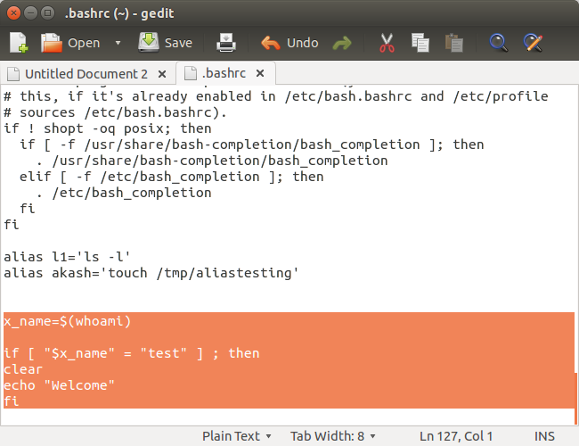
13.Install zip package.
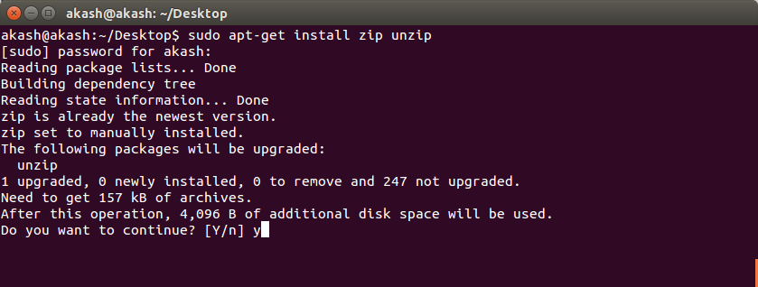
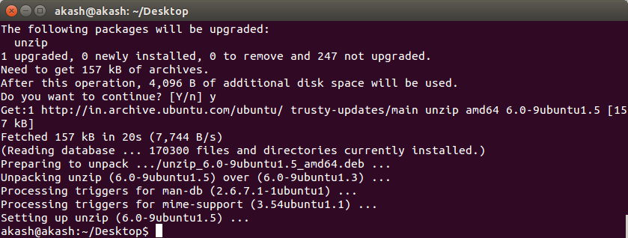
14.Compress "output" and "password_backup" files into a tar ball. List the files present inside the tar created.

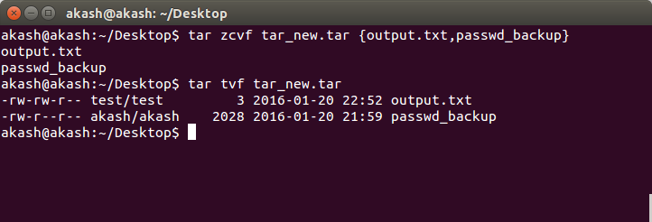

15. scp this file to test user

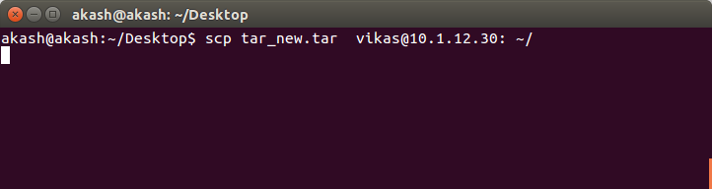

16. Unzip this tar bar by logging into the remote server.

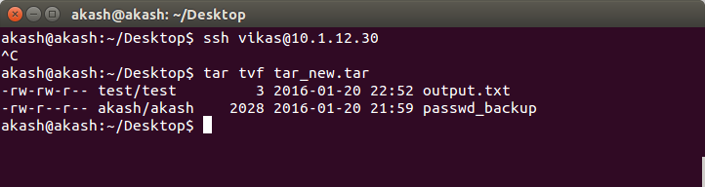

17. Download any image from web and move to desktop

